

UNIVERSITY OF BUEA
Faculty of Engineering & Technology
Department of Network Engineering
CEF478: Network Administration

Lab 1: Core Network Services DHCP, DNS, NTP on Router and Server

GROUP 5 MEMBERS

ECHUNDIP CARL-LAWRENCE | FE23A040
FONGANG FAITH ACHUO | FE23A059
OBIOMA OBI FODJO | FE23A133
BERINYUY GILLES KILALON | FE23A024
TAMBE RAMSON | FE23A156
BESSONG TAKANG TABOT | FE23A025

Lecturer: Dr Engr Forcha Glen
2025-2026 academic year/ Semester 2
June,2026

Table of Contents
- HONESTY REPORT
2. ABSTRACT: 2
3. OBJECTIVES 3
4. PRELAB QUESTIONS 3
5. Design and Addressing 5
6. METHODOLOGY 5

- Honesty report
Task | Responsible member | Contributions | Reviewers
Prelab Questions | ECHUNDIP CARL-LAWRENCE | FONGANG FAITH ACHUO | OBIOMA OBI FODJO
Implementations | FONGANG FAITH ACHUO  TAMBE RAMSON | ECHUNDIP CARL-LAWRENCE | BERINYUY GILLES KILALON
Testing and debugging | FONGANG FAITH ACHUO | BERINYUY GILLES KILALON | BESSONG TAKANG TABOT
Report Writing | BERINYUY GILLES KILALON  BESSONG TAKANG TABOT | TAMBE RAMSON | TAMBE RAMSON  OBIOMA OBI FODJO

2. ABSTRACT:
This laboratory exercise focused on the implementation of essential core network services including DHCP, DNS, NTP, VLAN configuration, and inter-VLAN routing using both Cisco Packet Tracer and virtual machines. The lab involved designing a segmented network topology consisting of management, client, and server VLANs. A Cisco router was configured using the router-on-a-stick technique to provide inter-VLAN communication through Fast Ethernet sub interfaces with 802.1Q encapsulation.
We then further configured our router to provide DHCP services dynamically to client devices within VLAN 20 and act as an NTP master for time synchronization across the network. A Windows Server virtual machine was prepared with a static IP address and configured to support DNS services for future Active Directory integration. Connectivity tests, DHCP lease verification, and NTP synchronization checks were carried out successfully.
In total the experiment demonstrated the practical implementation of VLAN segmentation, centralized IP management, and network service integration in both simulated and physical environments. Challenges encountered included VLAN trunk troubleshooting and virtual machine network adapter configuration. Overall, the lab provided practical understanding of foundational enterprise networking concepts and service deployment techniques.

3. OBJECTIVES
Our main objectives of this laboratory exercise were:
- To design a network topology using VLANs for management, clients, and servers.
- To configure VLANs and inter-VLAN routing using router-on-a-stick.
- To configure DHCP services on a Cisco router.
- To configure the router as an NTP master.
- To prepare a Windows Server VM with a static IP address.
- To configure DNS forwarding to the Windows Server VM.
- To verify communication between VLANs and network devices.

4. PRELAB QUESTIONS
- DHCP Operation
- The four steps of the DHCP handshake
- DISCOVER: The client broadcasts (255.255.255.255) on UDP port 68 seeking any available DHCP server. It is a broadcast.
- OFFER: The server responds with an available IP, subnet mask, gateway and lease time. Typically, a broadcast (since the client has no IP yet), though some implementations unicast to the client’s MAC.
- REQUEST: The client broadcasts it’s acceptance of the offered IP (also informing other servers that their offers are declined) It is a broadcast
- ACKNOWLEDGE: The server confirms the lease. This is unicast (or broadcast depending on the client’s broadcast flag).
- Why use ip dhcp excluded-address? Routers, servers and printers need fixed IPs. Without exclusion, the DHCP pool might hand those same addresses to random clients, causing IP conflicts that break connectivity for critical devices.
- DHCP across subnets DHCP, Relay Agent: If the client is on a different subnet than the DHCP server, a DHCP relay agent (configured with ip helper-address <server-ip> on the router interface facing the client) intercepts the broadcast, converts it to a unicast packet, and forwards it to the DHCP server. The server then replies back through the relay.

2.DNS and Active Directory Integration
- Why does Active Directory require DNS? AD uses DNS to locate domain controllers and services. Clients query DNS for SRV records to find the LDAP service (for authentication) and Kerberos (for ticket-granting). Without DNS, clients cannot locate the DC at all.
- Why should clients use the domain controller as primary DNS? The DC's DNS server holds the `netlab.local` zone with all internal SRV and A records. Public DNS servers (e.g., 8.8.8.8) don't know about internal names, so domain login, folder redirection, and other AD-dependent services would fail if clients used an external DNS.

3. NTP Significance
- NTP Stratum Stratum indicates the distance from a reference clock. Stratum 0 is an atomic/GPS clock. Stratum 1 is a server directly synced to a stratum 0 source. Each hop adds one stratum level. An NTP master actively provides time to clients; an NTP client synchronizes its clock from the master and does not serve time to others.
With ntp master 1 on the Cisco 1800, the router declares itself a stratum-1 source (even without an upstream reference), making it the authoritative time source for the local network.
- Clocks out of sync by more than 5 minutes: Kerberos authentication will fail. Kerberos (used by Active Directory for all logins) enforces a maximum 5-minute clock skew. If two machines differ by more than 5 minutes, authentication tickets are rejected, meaning users cannot log in to the domain, and services like folder redirection and Group Policy application will break.

4. VLANs and Inter-VLAN Routing
- Diagram, VLAN port assignments:
R1
Fa0/0 Trunk

f
f

VLAN TRUNK

SW1

f
f

- Purpose of encapsulation dot1Q on the router sub-interface the physical trunk link carries frames from multiple VLANs, each tagged with a VLAN ID per the IEEE 802.1Q standard. The encapsulation dot1Q <vlan-id> command tells the router which VLAN tag to strip/add on that sub-interface, so it knows which VLAN's traffic to process. Without it, the router cannot distinguish which VLAN a frame belongs to.
- Why does each VLAN need a default gateway? Devices can communicate directly only within the same subnet. To reach a device in a different VLAN/subnet, traffic must be sent to the default gateway (the router sub-interface IP), which then routes it to the correct destination. Without a gateway, cross-VLAN communication is impossible.

5. Design and Addressing
Using 192.168.20.0/24 as the base:
VLAN | Purpose | Hosts Needed | Subnet | Mask | Usable Range
VLAN 20 | Clients | 50 | 192.168.20.0 | /26 (255.255.255.192) | .1-.62
VLAN 30 | Servers | 10 | 192.168.30.0 | /28 (255.255.255.240) | .1-.14
VLAN 10 | Management | 5 | 192.168.10.0 | /29 (255.255.255.248) | .1-.6

- Router sub-interface and server addresses
- Router sub-interface (VLAN 20): 192.168.20.1 / 255.255.255.0
- Server (VLAN 30): 192.168.30.10 / 255.255.255.0, gateway 192.168.30.1

6. METHODOLOGY
Network Topology Design
Our network consisted of the following devices:
- One Cisco router (1841 / Cisco 1800 Series)
- One Cisco switch (2960 / Catalyst 2950)
- One Windows Server VM
- Two client PCs
VLAN Allocation
VLAN | Purpose | Network
VLAN 10 | Management | 192.168.10.0/24
VLAN 20 | Clients | 192.168.20.0/24
VLAN 30 | Servers | 192.168.30.0/24

VLAN and Routing Strategy
Router-on-a-stick was implemented using FastEthernet0/0 sub interfaces configured with 802.1Q encapsulation. The switch trunk port connected to the router carried VLAN traffic for VLANs 10, 20, and 30
Service Configuration Steps
DHCP Configuration
The router was configured to dynamically assign IP addresses to VLAN 20 clients.
DNS Configuration
A Windows Server VM with IP address 192.168.30.10 was configured as the DNS server.
NTP Configuration
The router was configured as an NTP master using:
ntp master 1

Tools Used
- Cisco Packet Tracer
- VirtualBox
- Windows Server 2019/2022
- Windows 10 VMs
- PuTTY
- PowerShell

Assumptions Made
- All Ethernet cables were functional.
- Devices supported VLAN tagging.
- Virtual machines had properly configured network adapters.

7. RESULTS
Packet Tracer Topology
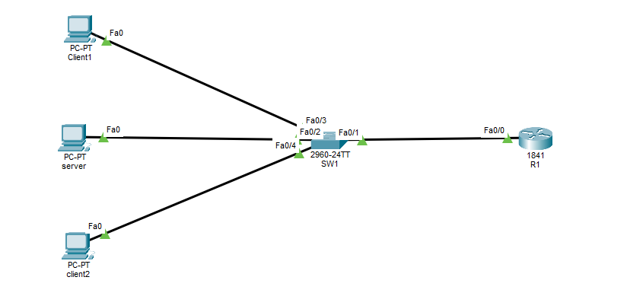
Switch Configuration
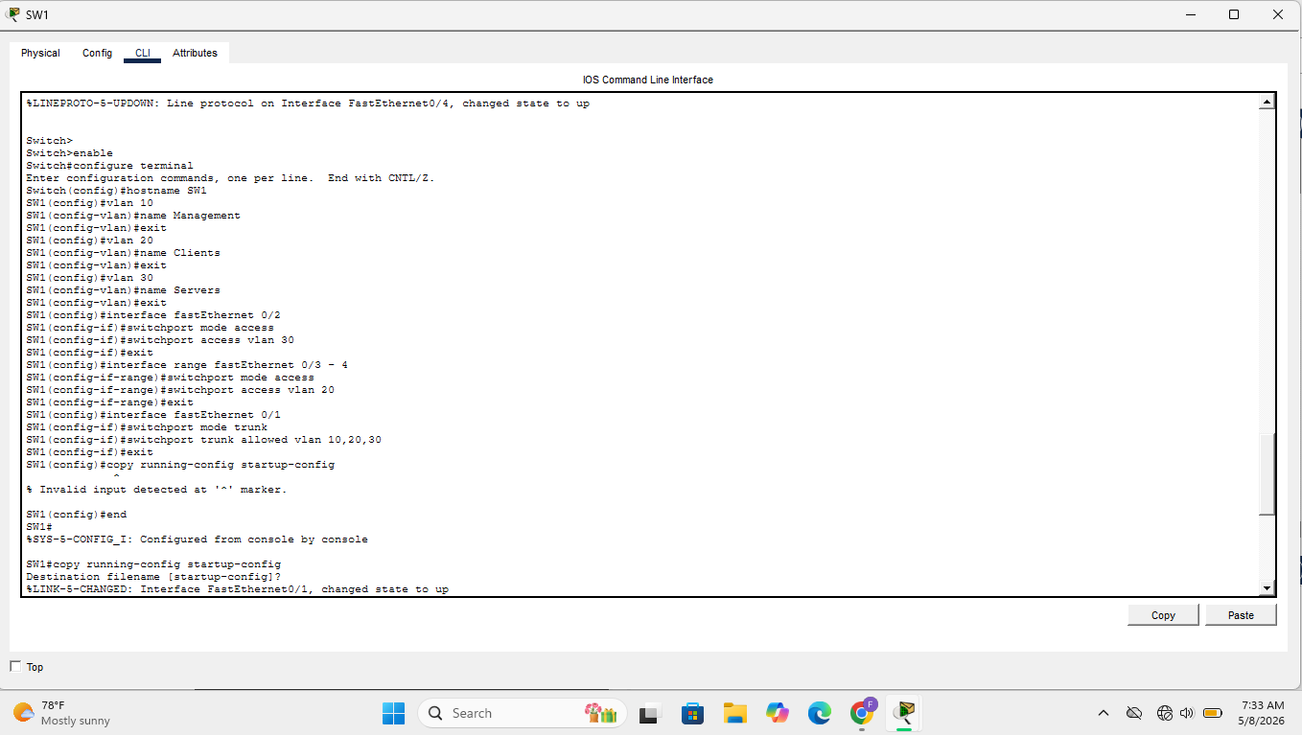
Router Configuration
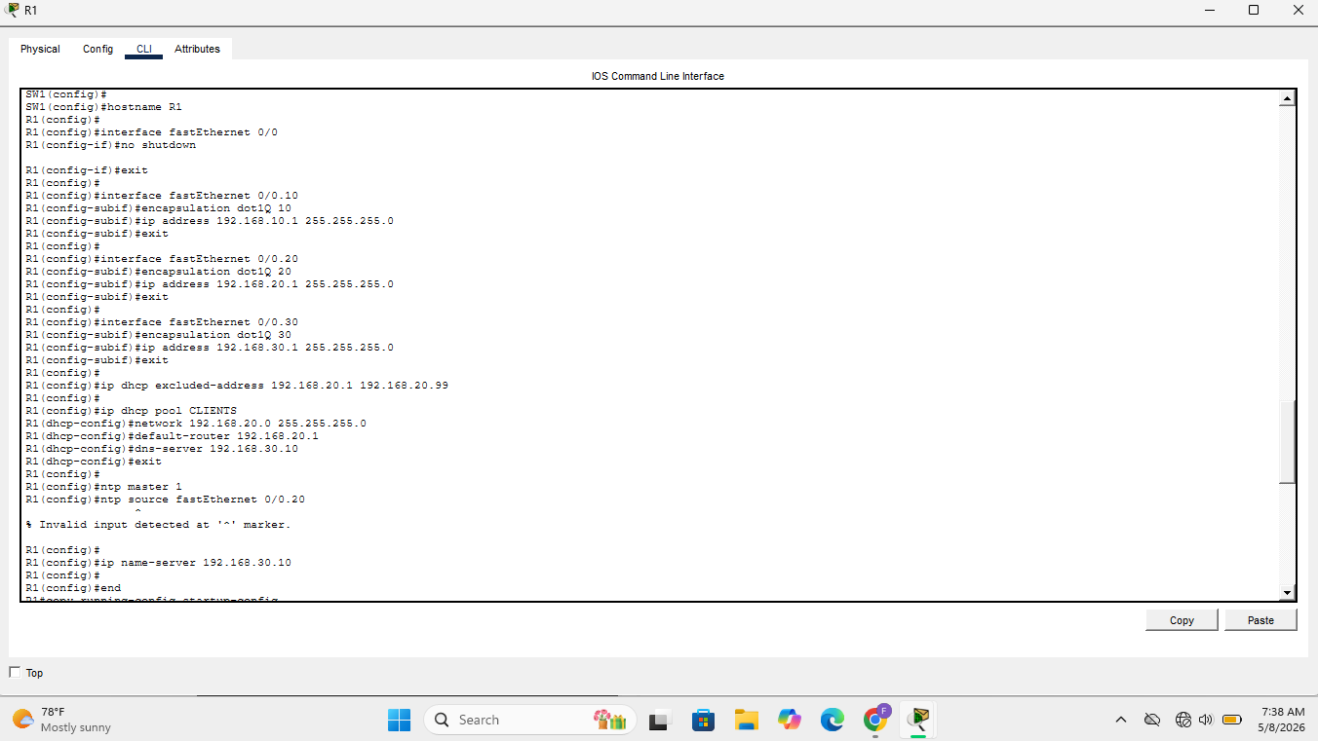
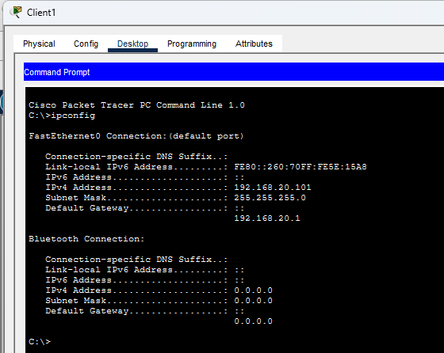
DHCP Verification

Connectivity Verification
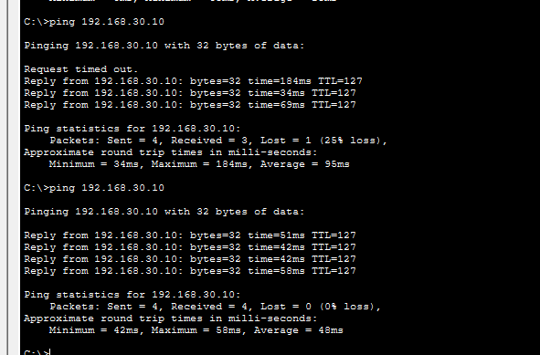
NTP Verification
The router synchronized time successfully.
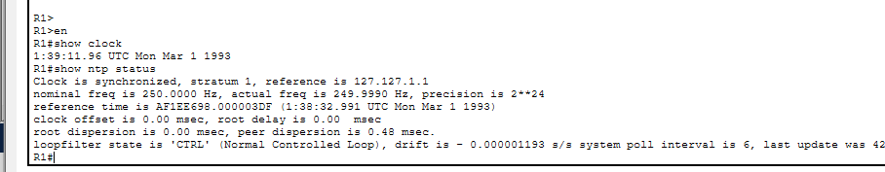

Task 5: Preparing Windows Server VM for DNS
After installing the Windows server, I enabled the following Static IP Configuration: Assigned IP 192.168.30.10, subnet 255.255.255.0, gateway 192.168.30.1, temporary DNS 8.8.8.8.

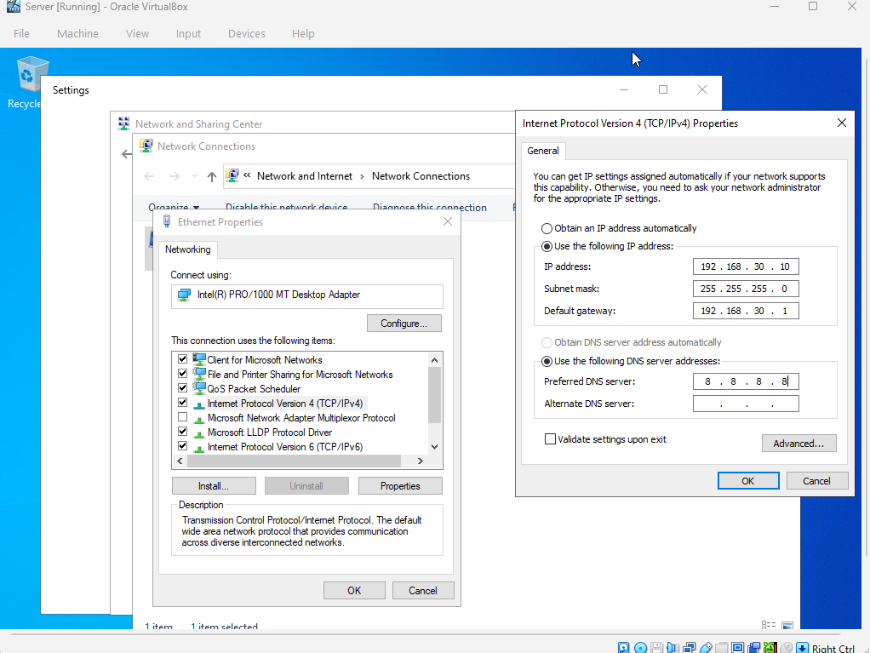
For DNS Role Installation: We Added DNS Server role via Server Manager.

Also, Router Setup: We Configured R1 with ip name-server 192.168.30.10 to forward DNS queries.
For the Connectivity Test: We Verified reachability using ping 192.168.30.10 from a client.

8. ANALYSIS AND DISCUSSION
The results obtained matched the expected outcomes. VLAN segmentation successfully isolated broadcast domains while inter-VLAN routing enabled communication between VLANs through the router sub interfaces. DHCP services dynamically assigned IP addresses to clients without manual configuration, demonstrating centralized IP management.
The NTP configuration successfully synchronized time across devices, which is important for authentication and logging in enterprise networks. DNS forwarding to the Windows Server VM prepared the environment for future Active Directory deployment.
One challenge encountered during virtual implementation was ensuring that the switch trunk link properly carried all VLANs. Misconfigured VLAN assignments initially prevented communication between clients and servers. Another challenge was configuring the VirtualBox network adapters to allow proper communication between virtual machines.
The physical Catalyst 2950 behaved similarly to the Packet Tracer simulation; however, command responses and interface initialization were slower on the actual hardware. Physical devices also required console access and proper cable management, unlike the simulation environment.
If scaling this network to a larger environment, additional routers, Layer 3 switches, redundancy protocols, and centralized monitoring systems would be implemented to improve performance and fault tolerance.

9. CONCLUSION
This laboratory exercise provided practical understanding of VLAN implementation, DHCP configuration, DNS preparation, and NTP synchronization within an enterprise network. The router-on-a-stick technique successfully enabled communication between VLANs while maintaining logical segmentation.
The experiment demonstrated how routers and switches cooperate to provide centralized network services and highlighted the importance of accurate configuration and verification procedures. Through both simulation and physical implementation, valuable experience was gained in configuring Cisco devices and virtualized server environments.
Future improvements could include implementing Active Directory Domain Services, redundancy mechanisms, and enhanced security configurations such as ACLs and port security.

10. REFERENCES
- Cisco Official Documentation
- Microsoft Learn Documentation
- Cisco Packet Tracer Resources
- VirtualBox Documentation
- MikroTik Documentation

